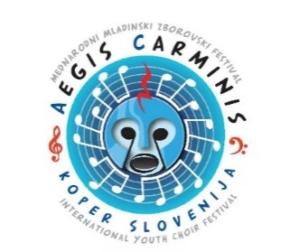

APPLICATION

COMPLETE IN CAPITAL LETTERS

PARTICIPANT INFO
Name |  | Surname |  |  |  |  | Category
Date of birth |  | Gender
ADRESS
Street, number |  | City, number |  |  |  |  | State
E-mail adress |  | Telephone number (mobile) |  |  |  |  | Fax number (optional)
INFO ABOUT STUDY
School institution  Mentor |  |  |  | Voice
PIANIST |  |  |  | MENTOR
Name and Surname |  |  |  | Name and Surname
Materials which must be included to the application:
- Repertoire form for 1st and 2nd Round,
- Short biography (approx. 500- 700 characters),
- A photo (in good resolution),
- Photocopy of identity document,
- After confirming the registered program, it is necessary to upload the recordings to YouTube or send the link no later than May 19th 2023
By signing, I confirm that I have read the terms of the competition and agree with them.

Place and date: |  |  |  |  |  | Signiture:
REPERTOIRE FORM - 1st ROUND
1 | The name of the composer |  | Composer's surname |  |  |  |  | Year of birth and death
 | The title of the composition |  |  |  | Author of the text
 | Composed (or published) in year |  | Publisher |  |  |  |  | Duration
2 | The name of the composer |  | Composer's surname |  |  |  |  | Year of birth and death
 | The title of the composition |  |  |  | Author of the text
 | Composed (or published) in year |  | Publisher |  |  |  |  | Duration
Only for Category C, D
3 | The name of the composer |  | Composer's surname |  |  |  |  | Year of birth and death
 | The title of the composition |  |  |  | Author of the text
 | Composed (or published) in year |  | Publisher |  |  |  |  | Duration
The Results of the 1st Round will be announced till May 29th, 2023
on Aegis carminis FB page and web page. Participants will be informed about jury decision as well by e-mail.

REPERTOIRE FORM - 2nd ROUND - FINALS
1 | The name of the composer | Composer's surname |  | Year of birth and death
 | The title of the composition |  | Author of the text
 | Composed (or published) in year | Publisher |  | Duration
2 | The name of the composer | Composer's surname |  | Year of birth and death
 | The title of the composition |  | Author of the text
 | Composed (or published) in year | Publisher |  | Duration
Only for Category C and D
3 | The name of the composer | Composer's surname |  | Year of birth and death
 | The title of the composition |  | Author of the text
 | Composed (or published) in year | Publisher |  | Duration
The Results of the 2nd Round - Finals will be announced at PRIZE GIVING CEREMONY on June 18th, 2023
as well as on Aegis carminis web page and FB page.

